COPYMASTER |  |  |  | COPY TONE: STANDARD / INFORMAL |  |  |  |  | VERSION: 1.0
Project Name: nitromg5 |  |  |  | Product Name: Acer Nitro MG5 MiniLED |  |  |  |  | Product Type: high quality miniled gaming display
CopyWriter: Clark Gurden |  |  |  | MKT: Michelle Chao |  |  |  |  | FCS: NA
RECENT CHANGES
//AGW Meta Content
Page Title (60) |  |  | Acer Nitro MG5 QD-MiniLED | QHD Gaming Display
Meta Description (160) |  |  | A QD-MiniLED QHD gaming monitor with up to 1152-zone local dimming, up to 210Hz refresh rate, up to 0.5ms response, Acer HDR1000 peak brightness, and wide color coverage.
//AGW Page Content / Banner
Banner Content - Product Name/Header (40) |  |  | Acer Nitro MG5 QD-MiniLED
Banner Content – Description (120) |  |  | Quantum Dot Gaming Monitor
Key Message/Page Intro
Key Message/Intro (220) |  |  | Designed for players who want a visible upgrade, not just higher numbers. MiniLED contrast and high refresh performance work together to deliver clearer motion, deeper blacks, and a more consistent image across fast-paced and cinematic content.
Logos / Badges / Awards
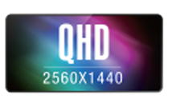 |  | 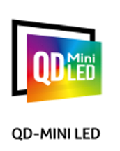 |  |  | 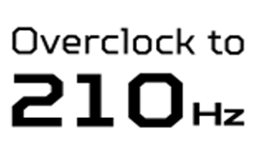 |  |  |  |  | 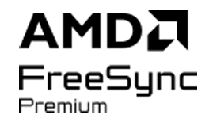 |  | 
Acer KSP 1
KSP Headline (40) |  |  | MiniLED Contrast with QHD Clarity
KSP Body (250) |  |  | Up to 1152-zone QD-MiniLED local dimming improves black depth and highlight control, while QHD resolution keeps fine detail sharp. Dark scenes stay readable, bright effects stay controlled, and contrast remains consistent across games, movies, and HDR content.
Overline (20) |  |  | Up to |  |  |  |  | QHD
Spec (30) |  |  | 1152 Local Dimming Zones |  |  |  |  | 2560 x 1440 Resolution
KSP Headline (40) |  |  | Quantum Dot Color Enhancement
KSP Body (250) |  |  | Quantum Dot technology delivers brighter, more intense colors that make game worlds feel deeper and more immersive. Environments stand out, effects pop, and visual detail stays clear, helping you track action and stay focused during fast gameplay.
Acer KSP 2
GRP KSP Headline (40) |  |  | Smooth Motion Without Compromise
GRP KSP Body (250) |  |  | High refresh performance keeps fast gameplay fluid and responsive, while fast response times help reduce blur and ghosting. AMD FreeSync™ Premium support helps minimize tearing and stutter, so motion stays clear during quick camera movement.
Overline (20) |  |  | Overclock up to |  |  |  |  | Up to
Spec (30) |  |  | 210 Hz Refresh Rate |  |  |  |  | 0.5ms Response Time
Acer KSP 3
KSP Headline (40) |  |  | Acer HDR1000 Brightness Control
KSP Body (220) |  |  | Higher peak brightness and precise backlight control add depth and clarity to both bright and dark scenes. Highlights stand out, shadows retain detail, and the image remains easy to read across different lighting conditions
Acer KSP 4
image
KSP Headline (40) |  |  | Wide Color with Reliable Accuracy
KSP Body (220) |  |  | Wide color coverage combined with accurate calibration helps colors appear consistent and natural. Games look vibrant without oversaturation, and creative work benefits from stable color output across different content types.
Overline (20) |  |  |  |  |  |  | 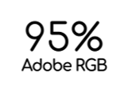 |  |  |  | 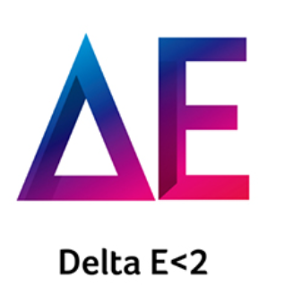
Acer KSP 5
KSP Headline (40) |  |  | Flexible Multitasking Support
KSP Body (220) |  |  | Picture-in-Picture and Picture-by-Picture modes let you view two sources at once. Keep a stream, guide, or second system visible without switching displays, supporting both focused play and everyday productivity.
Acer KSP 6
KSP Headline (40) |  |  | Designed For Flexible Setups
KSP Body (220) |  |  | A slim-bezel design and VESA mounting support make it easy to fit into a wide range of desk and arm-mounted setups. Tilt adjustment helps fine-tune viewing comfort, whether you are gaming for hours or switching between work and entertainment.
Disclaimers
 | The terms HDMI and HDMI High-Definition Multimedia Interface and the HDMI Logo are trademarks or registered trademarks of HDMI Licensing Administrator, Inc. in the United States and other countries.
 | AMD FreeSync/FreeSync Premium/FreeSync Premium Pro technology requires AMD Radeon graphics and a display certified by AMD. See www.amd.com/freesync for complete details. Confirm capability with your system or display manufacturer before purchase.
 | Specifications may vary depending on model and/or region. All models subject to availability.
 | Actual refresh rates may vary depending on model and/or region, computer specifications/hardware and/or set up.
 | Up to 210Hz refresh rate is achievable through overclocking via DisplayPort. Actual performance may vary depending on system configuration and settings.
 | NVIDIA® G-SYNC® Compatible support may vary by model and region.

